**White Bracket Fan**

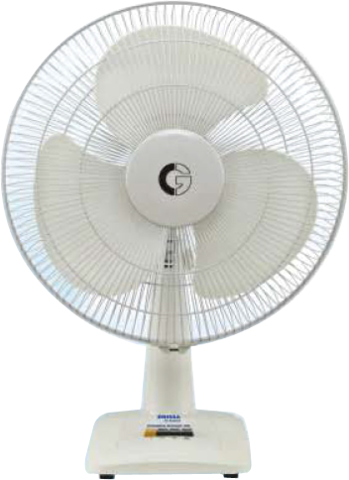

**Key Features  
  
AC/DC Ceiling Fan - Remote Control - 56" - White  
 Operable Voltage: 12V & 220 AC/DC  
 Power Consumption: 36watts  
 Pure Copper Winding, Brushless Motor  
 High Speed @ 320RPM  
 Metalic Body Price per Unit: $250/-**

**CORPORATE OFFICE**

    1300 E. Control Tower Rd.  
    Suite 216 Block L3  
    Englewood CO 80112  
 Phone: 720.974.7878  
    Toll Free: 1.877.929.7878  
    Email: [info@choicescreening.com](mailto:info@choicescreening.com)